Antoine Motte, Oraka Efetobo & Phillip Wilson

Title: - Sayless Customs

Clients: - The founders of Sayless Customs

Goals: - To organize and enhance Sayless Customs web page. Right now it’s a singular webpage and you have to scroll don to find what you need. We intend to create multiple pages and add more attractive features. They are getting views but not as much business per click, hopefully making the website easier to navigate will rectify this problem.

Audience

Customers: The customer base are people who want trendy custom one of a kind items that fit their personal style. This fits perfectly in the university age group, because many people want to stand out when it comes to fashion.

Visitors: people from the age of 18-35, who like to dress nice and add personal touches that bring a certain type of flair. They are the trendsetters who like to have clothes that are unique.

Journey map: I am a 23-year-old student and I would like to find original closet and on the home page, we would get to scroll to see the idea of the workshop. Afterwards we go on the shop page to see if we are satisfied with the closet.

Roadmap: We will first sit down and get a better picture of what exactly the sayless customs team wants. We want to keep their vision the same, just make their site easier to use. We can show a couple mockups of what it could possibly look like. We will let them decide on what route the site will take and leave all creativity to them. We will create the site as close as we can and present it to the client. Let them use it to see what else they would like to modify. We will also create several possible additions that they might not have thought of. Once its to their specifications the site will be tested and then go live.

Currently we are in the beginning stage of seeing what Sayless wants to have done. So in the very beginning of the roadmap.

Inspiration sites:

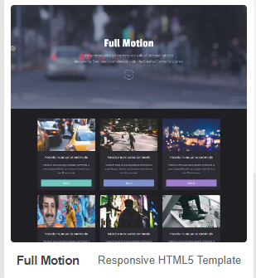 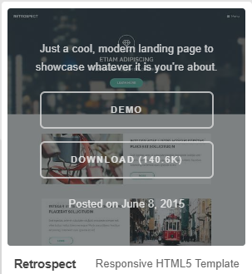

Color palette that has been requested

